**Case Study: HR Analytics using Power BI**

**Problem Statement**

In today's fast-paced and increasingly competitive business landscape, organizations are recognizing the pivotal role of Human Resource Management (HRM) in driving organizational success. Traditionally viewed as an administrative function responsible for personnel management, HRM has evolved into a strategic partner essential for achieving business objectives. At the heart of this evolution lies HR Analytics, a data-driven approach that empowers HR professionals to make informed decisions, optimize workforce performance, and enhance employee engagement.

HR Analytics involves the systematic collection, analysis, and interpretation of data pertaining to various aspects of the workforce, including recruitment, retention, performance, and employee satisfaction. By leveraging advanced analytics techniques and technologies, such as predictive modelling, machine learning, and data visualization tools like Power BI, organizations can unlock valuable insights that drive strategic HR initiatives.

The increasing availability of data within organizations, coupled with advancements in analytics capabilities, has fuelled the adoption of HR Analytics across industries. Today, companies of all sizes are harnessing the power of data to gain a deeper understanding of their workforce dynamics and to proactively address HR challenges. Whether it's identifying talent gaps, predicting turnover, or optimizing recruitment strategies, HR Analytics enables organizations to align their human capital with their overarching business objectives.

Against this backdrop, the adoption of HR Analytics represents a paradigm shift in how organizations approach talent management and HR decision-making. Rather than relying solely on intuition or past experiences, HR professionals now have access to empirical evidence and insights derived from data analysis. This data-driven approach not only enhances the accuracy and effectiveness of HR interventions but also enables organizations to stay agile and responsive to changing market dynamics.

The emergence of tools like Power BI has democratized data analytics, allowing HR professionals to create interactive dashboards and visualizations without extensive technical expertise. With Power BI, organizations can consolidate HR data from disparate sources, transform it into actionable insights, and communicate findings effectively across the organization. This democratization of analytics empowers HR stakeholders at all levels to leverage data in their decision-making processes, fostering a culture of evidence-based HRM.

In this context, this case study explores the implementation of HR Analytics using Power BI Dashboard. By examining the process, methodologies, results, and impact of leveraging HR Analytics, this case study aims to demonstrate the transformative potential of data-driven HRM in driving organizational excellence.

**Importing dataset in Power BI**

* The dataset for the HR Analytics project is available for download from Kaggle.
* It contains approximately 1481 rows and 30 features, providing a comprehensive dataset for analysis.
* Prior to analysis, data pre-processing is required to address anomalies and ensure data quality.
* Data pre-processing involves steps such as handling missing values, removing duplicates, and addressing outliers.
* Additionally, data cleaning techniques may be employed to standardize data formats and ensure consistency.

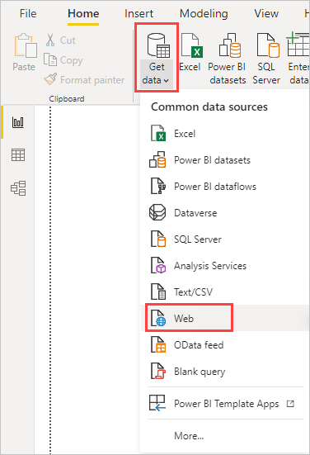Step 1: Click on the "Get Data" button located in the Home tab of the Power BI Desktop interface.

Figure 1

Step 2: From the dropdown menu, choose "Excel" as the data source. This will open a file explorer window.

Step 3: Navigate to the location where your Excel file is stored and select it. Click "Open" to proceed.

Step 4: In the Navigator window, you'll see a list of sheets and tables available in the Excel file. Select the specific sheet or table you want to import by checking the box next to it. You can also preview the data by clicking on it.

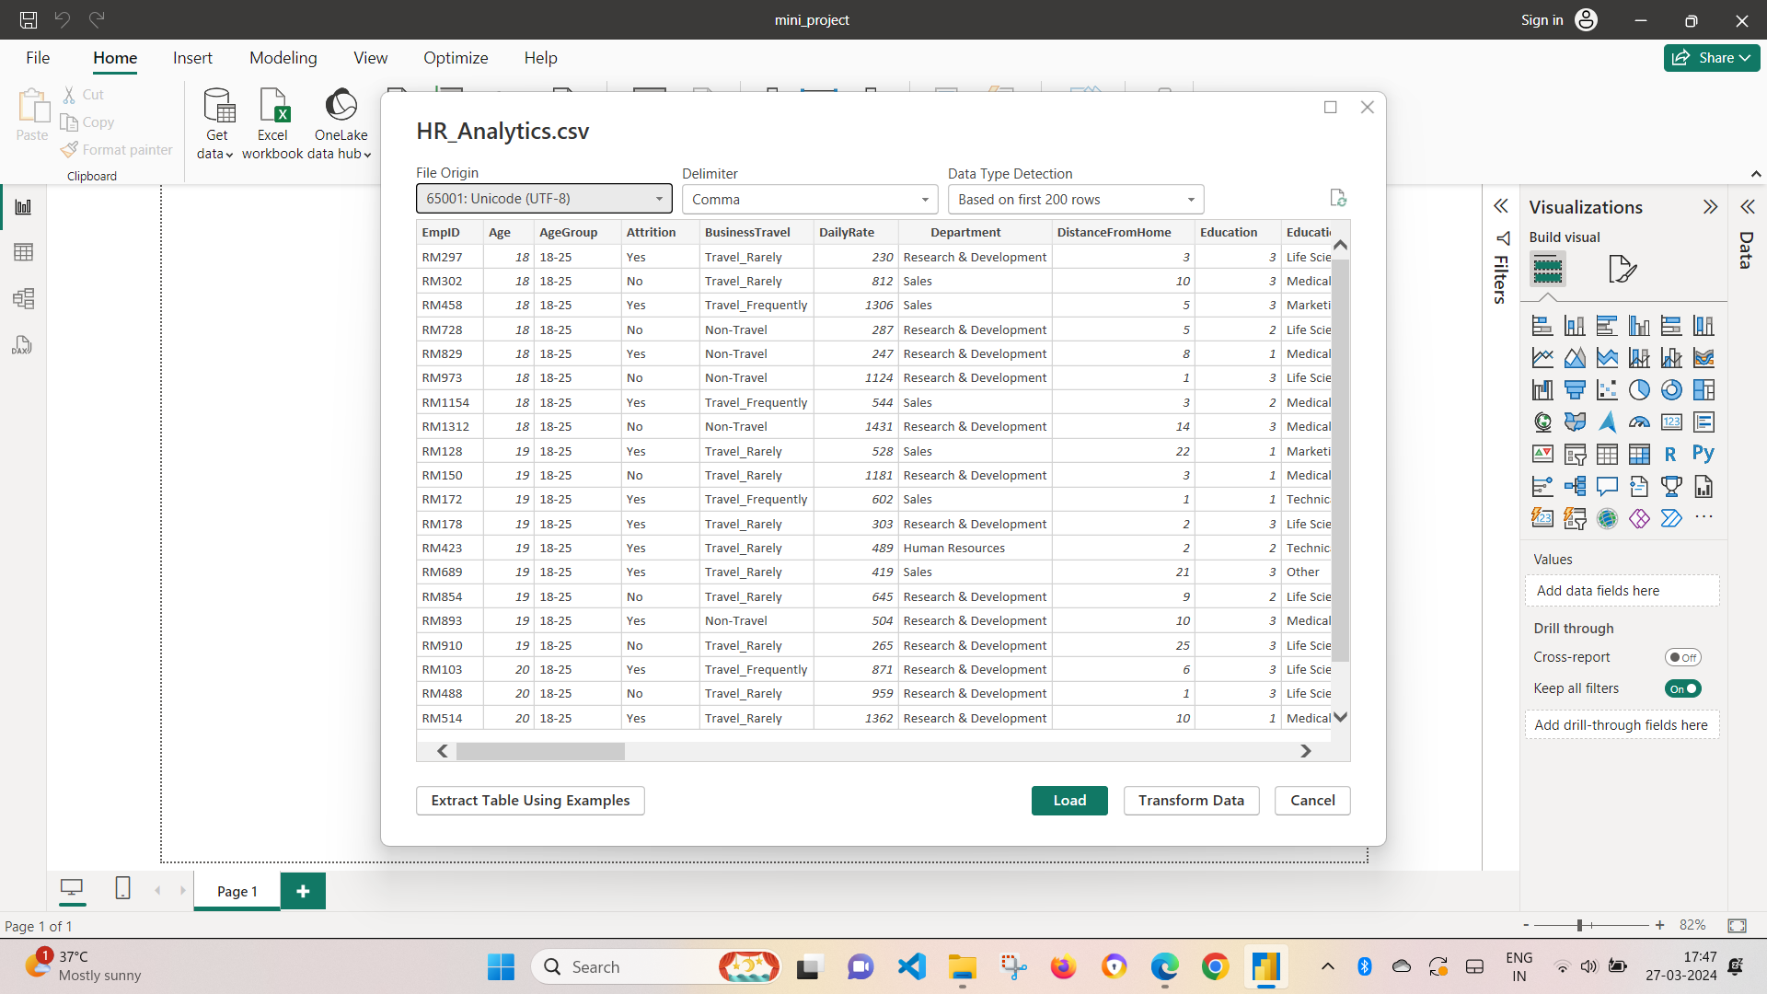

Figure 2

**Transforming data**

1. **Deleting Redundant Columns**: Redundant columns that did not contribute to the analysis were identified and removed from the dataset. This streamlined the data and focused on pertinent information.
2. **Renaming the Columns:** Column names were revised to be more descriptive and user-friendly, facilitating easier interpretation and analysis in Power BI.

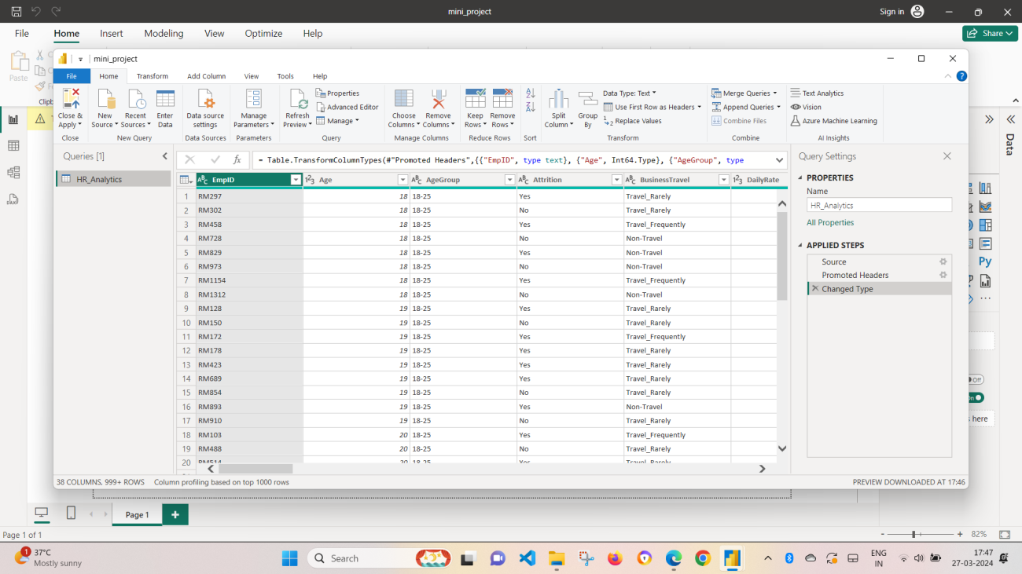

Figure 3

1. **Dropping Duplicates:** Duplicate rows were eliminated to maintain data integrity and prevent inaccuracies in analysis results. This step was crucial for ensuring the reliability of the dataset.
2. **Cleaning Individual Columns:** Each column underwent cleaning procedures tailored to its specific data type and content. This included formatting dates, converting data types, and standardizing text values to ensure consistency across the dataset.
3. **Removing NaN Values:** NaN values, indicative of missing or undefined data, were identified and removed from the dataset. This ensured that the dataset was complete and devoid of any anomalies that could skew analysis results.

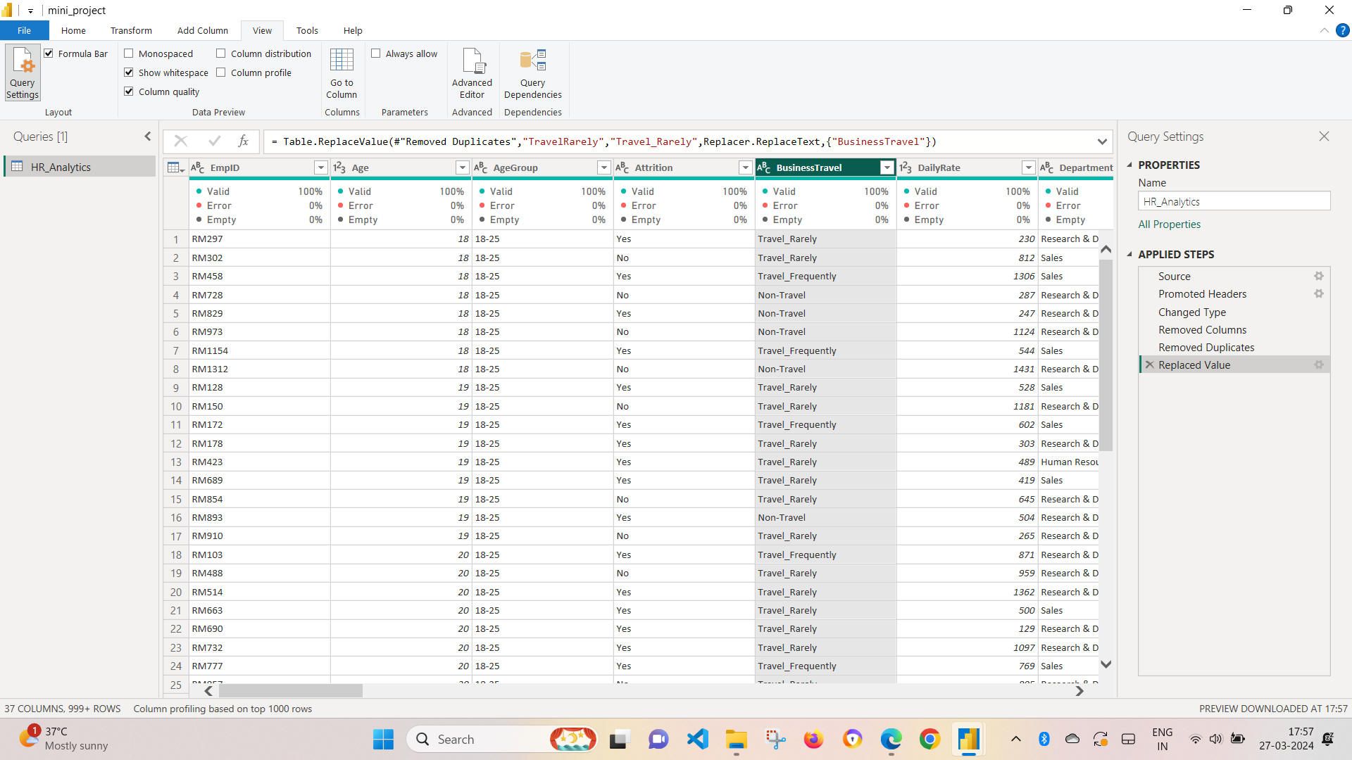

Figure 4

After we have completed all the data transformation, click close and apply

**Building Dashboard**

In Power BI, users have access to a diverse range of visualizations to suit their specific analytical needs. These visualizations can be easily added to a dashboard through a drag-and-drop interface, making it simple to create dynamic and informative displays of data. On the right-hand side of the Power BI interface, users can find a box containing a variety of graphs and charts, allowing for quick selection and implementation onto the dashboard canvas.

For our HR Analytics dashboard, we have implemented the following graphs:

1. **Donut Chart:** A variation of the pie chart, the donut chart allows users to visualize proportions of data in a circular format with a hole in the centre. It is useful for displaying percentages or parts-of-a-whole relationships.

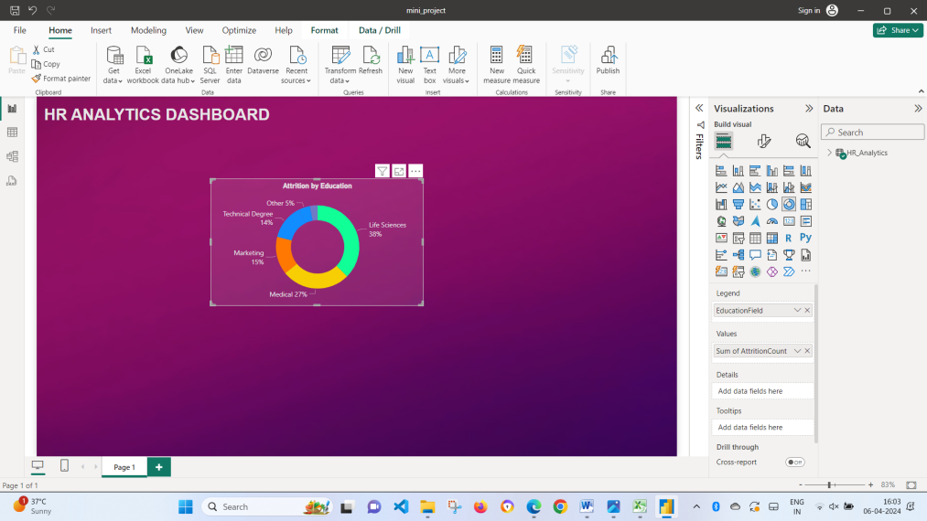

Figure 5

1. **Stacked Column Chart:** The stacked column chart presents data in vertical columns, where segments of each column are stacked on top of each other. This chart is effective for comparing multiple categories across different segments and showing their cumulative totals.
2. **Stacked Bar Chart:** Similar to the stacked column chart, the stacked bar chart displays data in horizontal bars with segments stacked on top of each other. It is particularly useful for comparing data across categories when horizontal space is limited.

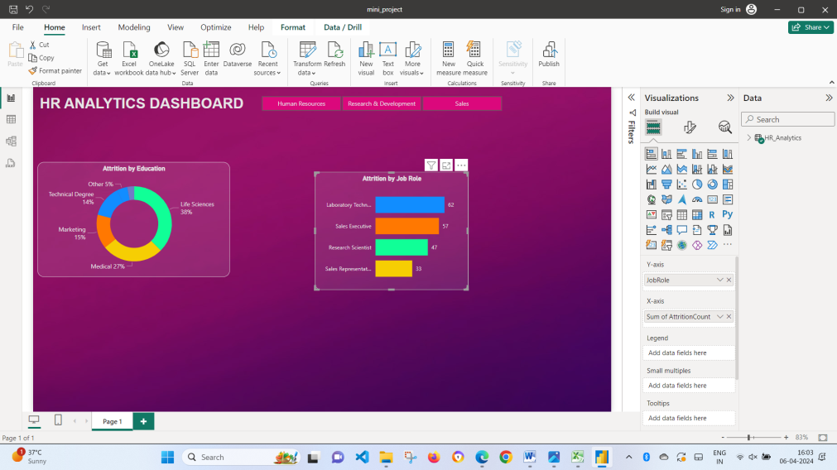

Figure 6

1. **Area Chart:** The area chart displays data as a series of data points connected by lines, with the area below the lines filled in with colour. It is useful for visualizing trends over time and comparing the magnitude of different variables.
2. **Matrix:** The matrix visualization presents data in a tabular format with rows and columns, allowing users to view intersections of data in a structured manner. It is useful for displaying multidimensional data and performing comparisons across different categories simultaneously.

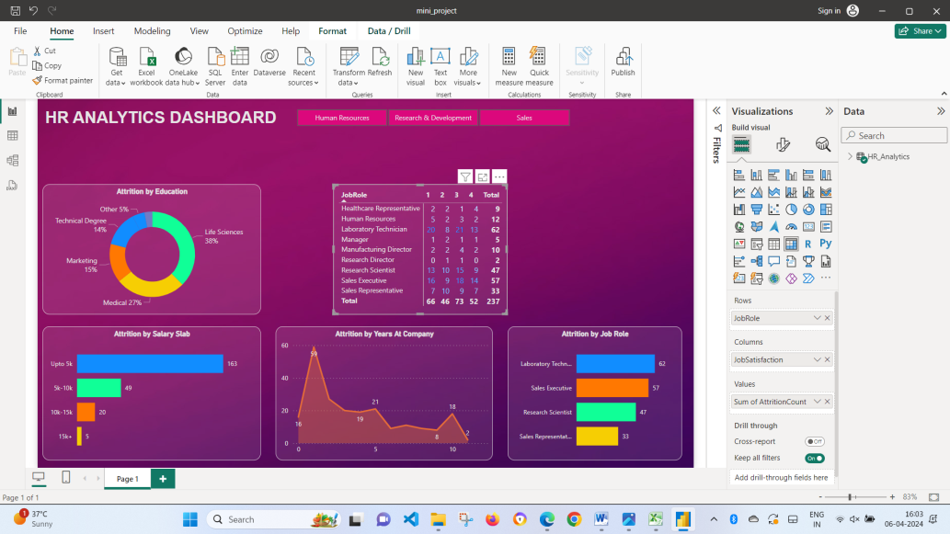

Figure 7

1. **Treemap**: The treemap visualization presents hierarchical data in a hierarchical layout, where each rectangle represents a category or subcategory, and the size of the rectangle corresponds to a quantitative measure. It is useful for visualizing the relative proportions of different categories within a dataset and identifying patterns or trends in hierarchical data structures.

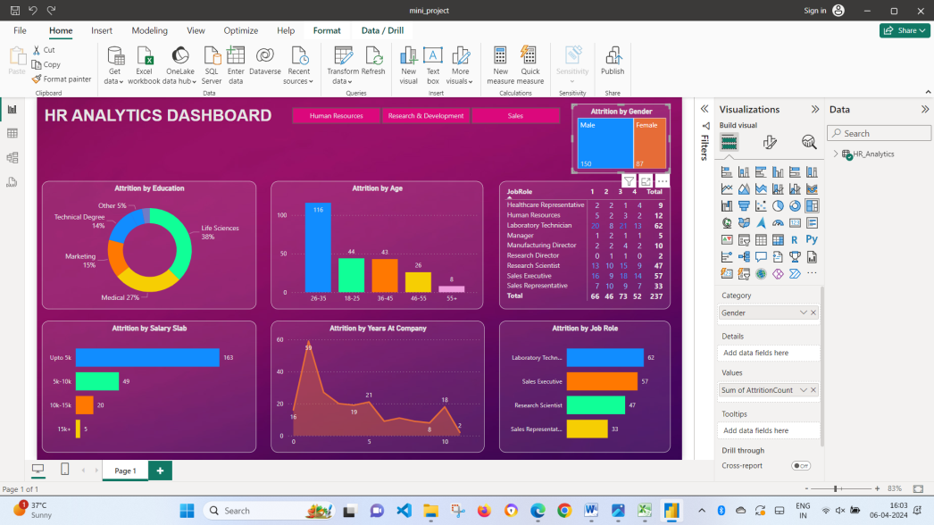

Figure 8

In addition to the diverse range of graphs and charts available in Power BI, we have incorporated several key performance indicators (KPIs) to provide stakeholders with actionable insights at a glance. These KPIs are strategically selected to align with the organization's HR objectives and priorities, allowing for quick assessment of performance and identification of areas for improvement.

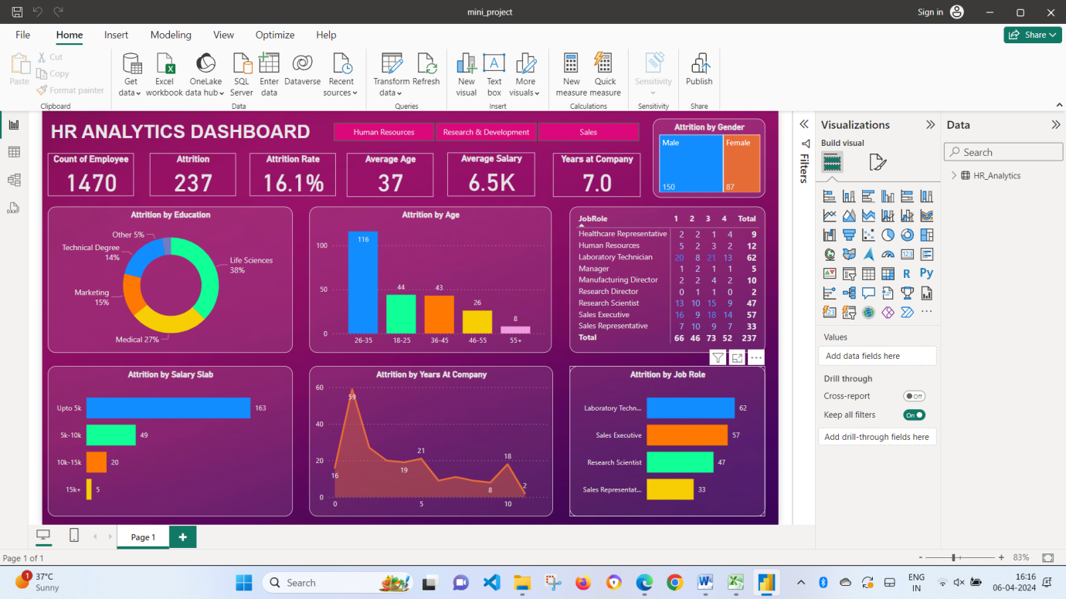

Figure 9

**Insights gained from HR Analytics Dashboard**

The attrition rate for the company stands at 16.1%, prominently displayed in the top right corner of the dashboard. This metric serves as a crucial indicator of employee turnover and highlights the extent to which the organization is experiencing workforce churn. A pie chart reveals a notable gender disparity in attrition rates. Men constitute a significant majority, accounting for 65% of employees who have left the company. This insight underscores a potential area of concern regarding gender-specific retention strategies.

Analysis depicted in the bar graph illuminates age-related attrition trends within the organization. Employees aged between 35 and 45 exhibit the highest likelihood of leaving, closely followed by those in the 18 to 25 age bracket. Understanding these age-specific patterns can inform targeted retention initiatives tailored to different age groups. The bar graph highlights the impact of job roles on attrition rates. Notably, laboratory technicians demonstrate the highest attrition rate among all job roles, with 62 employees leaving the company. Sales representatives and research scientists also experience significant attrition, indicating potential challenges in retaining talent within these roles.

Analysis conducted through the matrix visualization uncovers an intriguing trend wherein employees providing positive ratings are also leaving the company. This suggests a potential disconnect between employee satisfaction levels and retention strategies, necessitating a deeper exploration of underlying factors contributing to attrition among high-performing individuals. The data reveals a common trend wherein a significant proportion of employees tend to leave the company within 1-2 years of joining. This underscores a challenge in retaining talent during the initial stages of employment and emphasizes the importance of implementing robust onboarding and retention programs to enhance employee engagement and loyalty.

A noteworthy observation emerges concerning the salary levels of departing employees, with up to 163 individuals leaving with salaries below 5,000 despite the average salary being 6,500. This suggests a potential correlation between salary satisfaction and attrition rates, highlighting the need for competitive compensation strategies to retain top talent effectively.

**Conclusion**

Through the deployment of HR Analytics via Power BI, we have unlocked a wealth of actionable insights vital for informed decision-making and strategic workforce management. The analysis of attrition rates, demographic trends, and job role dynamics has provided us with a comprehensive understanding of our human capital landscape, paving the way for targeted interventions to drive organizational excellence.

Understanding the nuances of attrition, particularly the gender and age-related trends, equips us with the knowledge needed to tailor retention strategies effectively. By addressing the specific challenges faced by employees in critical roles such as laboratory technicians and sales representatives, we can mitigate talent loss and foster a more stable workforce environment.

The identification of a potential disconnect between employee satisfaction levels and retention strategies underscores the importance of aligning engagement initiatives with retention efforts. By ensuring that high-performing individuals are retained within the organization, we can safeguard our talent pool and maintain a competitive edge in the market.

Moreover, the observation regarding salary levels of departing employees highlights the significance of competitive compensation strategies in talent retention. By addressing salary disparities and benchmarking against industry standards, we can enhance our attractiveness as an employer and improve retention rates.

Moving forward, continued monitoring and analysis of HR metrics will be essential to adapt to evolving workforce dynamics and sustain organizational growth. By embracing a data-driven approach to HR management, we can foster a culture of innovation, agility, and excellence, driving long-term success and competitive advantage in the marketplace.